# **Weekly Report – W5 Fall 2022**

## **Problem**

### *Part 1: Theory*

1. Equivalent torque/force exerted position on SRA: owing to the properties of soft materials, the SRA should be a continuous model. Unlike the rigid robots composed of multiple links, the force/torque provided by actuator or motor can be seen as acting on the joint, but for SRA, we cannot directly figure out the position of the joints.
2. Interaction force modelling via angle control: as shown in the last week’s report, the interaction force between human and SRA was modelled by a first order system, if we assume the stiffness term (the distance between human’s back and the base of SRA) domains the force function, even some minor precision error will cause a lot difference, thereby we need to use some other methods like angle control.
3. Inertia tensor in interaction force: in some papers, the inertia term was ignored in modelling interaction force between human body and SRA, we need to discover some reasons and applicable conditions in depth.
4. Human body mechanics to identify damping and stiffness of human: to model the interaction force between human body and SRA, the most straightforward way is to find if there are any past physical experiments to test these parameters.

### *Part 2: Simulation*

1. Simulation about a ball falling down in a 2D plane, and the ball is tied by two SRAs, each of them is composed of two segments. The elastic characteristic (damping and stiffness) of SRA needs to be considered when modelling. Animate the dynamic process and evaluate it.
2. Simulation about a single SRA with two links colliding with a rigid block in 2D surface, all the other conditions are the same as the last simulation, evaluate and visualize the dynamic process.

## **Solution**

### *Part 1*

1. In the past week, I have investigated several papers about pneumatic actuators of SRA. Pneumatic actuated SRAs normally have multiple chambers inflated with air, assisted by cable-driven mode. Some examples are shown as follows.

There is one thing worth to note that the torque or force is not directly acting on the joint for **purely** pneumatic SRAs, for a certain configuration, there must be a certain force exerted along the configuration curve (or pressure, or how much air is compressed into the chamber), just like a cable-driven model.

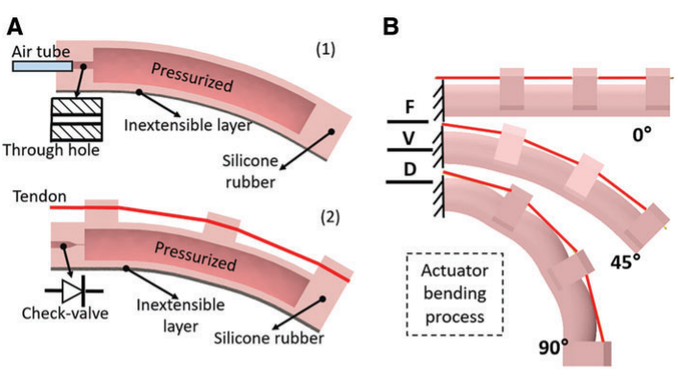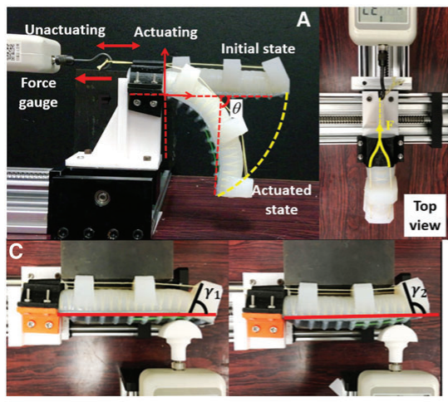

**Fig. W5-1** Examples of precharged pneumatic SRA [1]

And furthermore, to realize different gestures for different links of SRA, the McKibben muscle has been used in Chase’s dissertation, the number of chambers is different for each link, if we do not consider any other effects, the force along the configuration can be simply seen as , where is the cross section area of the segment, or we can use a more specific example from cable-driven model to illustrate it.

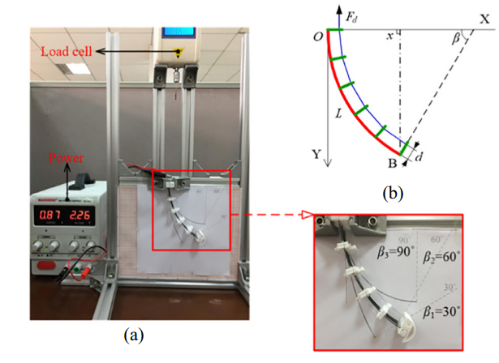

**Fig. W5-2** Analysis of bend shape for soft robot [2]

And the actuator force exerted on the end-effector can be calculated using the following equation:

1. As depicted in the Problem section, if we insist on using position control to model the interaction force between human body (actually human’s back) and SRA (base), the magnitude of distance itself between them is very small, so the accuracy of the generalized force large relies on the precision of the sensors. Since the angle change when human is going to fall down is more obvious, it could increase the accuracy of force modelling.

Baimyshev *et al.* [3] developed wearable gas thruster for fall prevention, which can provide a reverse propulsion to push the human when he falls backwards and help him to regain balance.

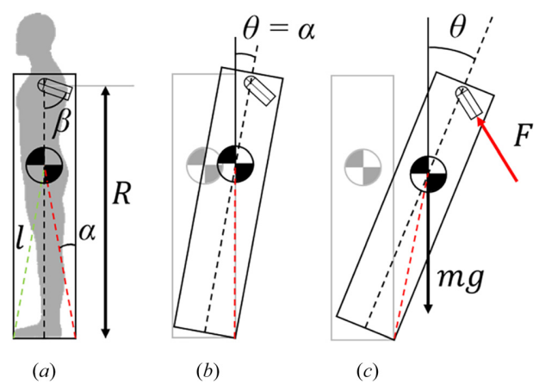

**Fig. W5-3** Rocking block when (a) stationary, (b) at fall angle, and (c) falling

The motion equation can be summarized as follows,

where all the geometry factors have all been defined in the figure above, in this case we can estimate the interaction force by

1. Some experiments [4] have been performed to find the human body characteristic via a cooperation task by the robot and the human as shown in the figure below.

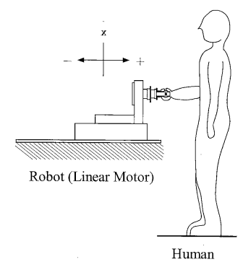

**Fig. W5-4** Experimental cooperation task by robot and the human

The interaction force can be written as

And the results showed that the muscle of the human arm possess high viscoelastic property at the starting of the movement and only minimum viscosity at the time of movement (like static and dynamic friction coefficient). However, the mass effect was almost constant (the supported data has been shown below), which can be ignored, and it was not explained from the point of view that compared with the inertia of robot, the human arm’s is very small. I’m just a little curious about it, maybe I can find some other similar physical experiments in the future in which there might exist better explanation.

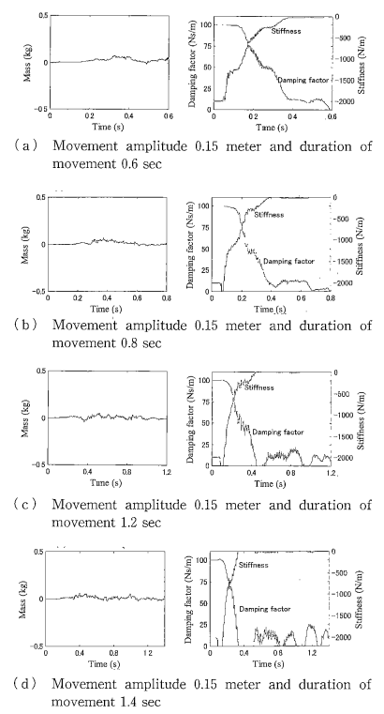

**Fig. W5-5** Impedance parameters calculated from the experimental data

1. Although I haven’t found any directly related research on measuring the stiffness and damping coefficients of human’s back, the method introduced in [4]

Assume is the sampling time, then we have the following definition of the velocity and acceleration of a certain point,

Plug Eq. (W5-5) and (W5-6) into Eq. (W5-4), we will obtain

where , and . Eq. (W5-7) is in a form of ARX (Auto Regressive eXogenous) model, the coefficients , and can be estimated by using Different Variants of the Recursive Least-squares method (System Identification Toolbox in MATLAB). Then the inertia, damping and stiffness can be determined.

### *Part 2*

1. (1). Assumption

* The model of SRA is set up based on the piecewise constant curvature (PCC) theory;
* As it is a 2D problem, we only have to consider the stiffness and damping of bending rather than twisting (the specific values for the parameters were referred from Chase’s dissertation);
* The only external force is gravitational force acting on the ball for stage 1;
* The two end-effectors are attached to two fixed points (same altitude) throughout the whole falling process;
* The curve at the ends connected with the wall and the ball is always tangential to the horizontal surface;
* We treat each SRA segment as three links, two for revolute and one for prismatic;
* In the transformation matrix, the z axis is always deemed to be along the axle of revolute or the prismatic direction.

(2). Model Description & Variable Definition

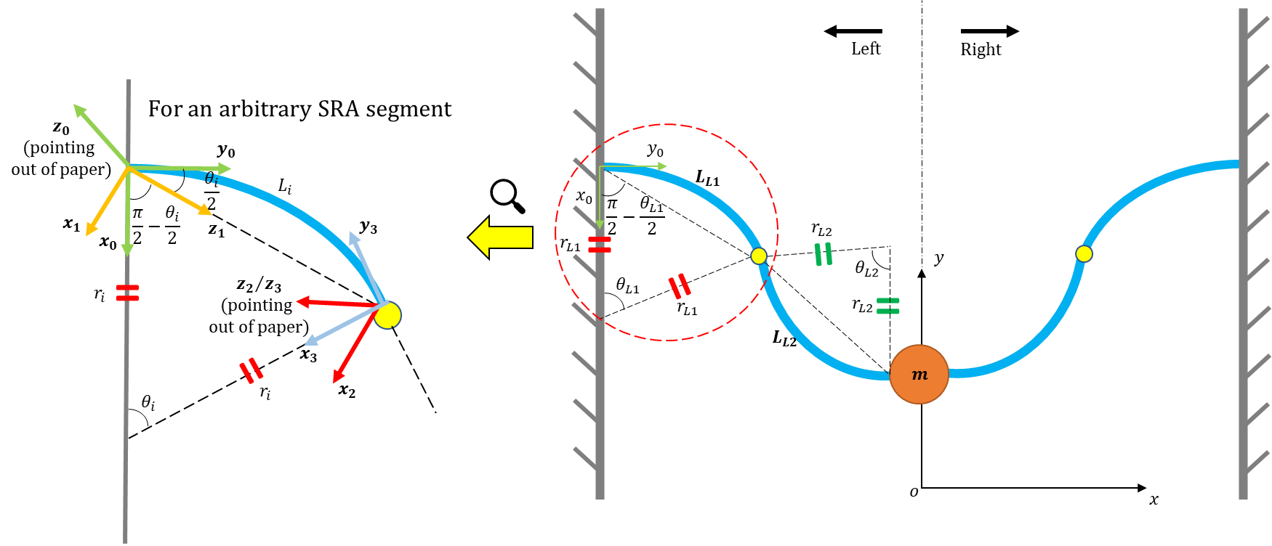

**Fig. W5-6** The schematic of the variable definition for Simulation 1

At the very beginning, I attempted to define the two bending angles as those between the chords and the horizontal line (as I read some similar modelling methods in books about biped walking control), but soon I found it is hard to apply for 3D case, so I turned back to use PCC model.

For an arbitrary link, the rotation matrix should be

And I have examined the correctness of the matrix for different values of , and it is proved to be right. The next step is to derive the governing equation of the system, but I have a few questions based on whether to bring in more variables or not (in the Difficulty part), it will affect the final format of the dynamics, maybe we can discuss it in the meeting.

1. Not finished yet, but I think this can be a little easier compared with the last simulation. The only thing I concern about is that if both of the two links are tangential about the joint all the time, if yes, we can divide the whole SRA by two parts (not by the joint) by the collision point, is it proper to assume there is no bouncing or bending for the part which is connected with the wall? Because in this stage, the introduction of friction at contact point and restitution coefficient will make the simulation even more complicated.

## **Difficulty**

My difficulty for this week mainly comes from simulation.

1. Temporarily we let the two arms connected with wall in the same altitude, and both sides are symmetric about the central line, so the force distribution on each end-effector will be , but what will the distribution be like if the length of SRA on each side is different or the grasping point is not in the same altitude? I think I need to make such adjustment about my code in advance or maybe not?
2. Although it is 2D model, actually it’s “3D”, for instance, for the link 1 in the left (in Fig. W5-6), the rotation matrix for bouncing up and down is different, we probably need to bring into another angle (can only be and ) rotating around axis?
3. Are the links about the joint continuous (tangent)? Or maybe we need to consider introducing a fourth variable, the angle between two chords for one side.

## **Plan**

1. Work on the simulation, complete the impact one at least.
2. Need to do more follow up study about how to derive the generalized force for pneumatic SRA.

## **Reference**

[1] Li, Y., Chen, Y., Ren, T., Li, Y. and Choi, S.H., 2018. Precharged pneumatic soft actuators and their applications to untethered soft robots. Soft robotics, 5(5), pp.567-575.

[2] Li, J., 2019. Position control based on the estimated bending force in a soft robot with tunable stiffness. Mechanical Systems and Signal Processing, 134, p.106335.

[3] Baimyshev, A., Finn-Henry, M., and Goldfarb, M. (May 19, 2022). "Feasibility of a Wearable Cold-Gas Thruster for Fall Prevention." ASME. J. Dyn. Sys., Meas., Control. August 2022; 144(8): 084501. <https://doi.org/10.1115/1.4054529>

[4] Rahman, M.M., Ikeura, R. and Mizutani, K., 2002. Investigation of the impedance characteristic of human arm for development of robots to cooperate with humans. JSME International Journal Series C Mechanical Systems, Machine Elements and Manufacturing, 45(2), pp.510-518.